

PITTSBURGH RADICAL REFERENCE
WELCOMES G20 PROTESTERS AND ALTERNATIVE MEDIA JOURNALISTS!

TABLE OF CONTENTS

Library Workers Are F***ing Awesome!.................................................................................... 3
Radical Reference………………………………………………………………………………… 3
Libraries in the Pittsburgh Region………………………………………………………………... 3 2

General G20 Information……………………………………………………………………….. 5
Organizations' Contact Information.………………………………………………………………5
People’s Guide to the G20………………………………………………………………………... 5
Free Internet Access……………………………………………………………………………….6
Calendar of Protests and Events………………………………………………………………….. 7

Legal Information……………………………………………………………………………….. 10
Legal Contact Information………………………………………………………………………... 10
Police Contact Information……………………………………………………………………….. 10
Know Your Rights………………………………………………………………………………… 11
To the Courthouse…………………………………………………………………………………12
Pending legislation from the Pittsburgh City Council…………………………………………….13

Travelers’ Aid……………………………………………………………………………………. 13
Public Transportation……………………………………………………………………………... 13
Bookstores, Infoshops, and Free Spaces…………………………………………………………..15 10
Cheap Lodging………………………………………………………………………………….....17
Vegetarian Food and Coffee Shops……………………………………………………………… ..17
Bathrooms……………………………………………………………………………………….. ..18
Basic Street Map………………………………………………………………………………… ..19
Maps of Downtown Pittsburgh……………………………………………………………………20

Medical Information……………………………………………………………………………...22
Local Hospitals………………………………………………………………………………….. ...22
MedExpress Urgent Care Centers (cheaper than emergency rooms)……………………………... 22
Free/Sliding-Scale Clinics………………………………………………………………………….23
Pittsburgh G20 Medics…………………………………………………………………………….24
Stay Healthy So You Can Stay in the Streets……………………………………………………. ..24

LIBRARY WORKERS ARE F***ING AWESOME!

Radical Reference
Radical Reference is a collective of volunteer library workers who believe in social justice and equality. Radical Reference began in 2004 as a service provided by library workers to assist demonstrators and activists at the Republican Convention in New York City. Since then, Radical Reference has continued to provide assistance to activists and people doing progressive research through their website and by providing workshops in the community. Activists and demonstrators may ask questions online which will be answered by progressive librarians. For more information or to ask a question, go to http://radicalreference.info.

Local collectives of Radical Reference are located all over the country. The Pittsburgh Collective put together this guide for activists and journalists who will be converging in Pittsburgh this September. If you'd like more information, or have a question for the Pittsburgh Radical Reference collective, you may reach us at pittsburghradicalreference@gmail.com.

G20 Alternative Resources
University of Pittsburgh librarians are working on a list of alternative web resources on the G20 (or globalization) as it relates to women, hunger, poverty, labor, racism, democracy, education and youth, health care, war and human rights. It will be posted on the People’s Summit website - www.peoplessummit.com - and on the website of the International Responsibilities Task Force of the Social Responsibilities Round Table of ALA (American Library Association) - http://www.pitt.edu/~ttwiss/irtf/.

Telefact is an informational telephone service run by University of Pittsburgh students that researches and answers callers' questions daily from 12pm-9pm. The service is free to use and can be reached at 412-624-FACT. Call with almost any type of question. “The scope of Telefact permits us to answer nearly any question conceivable.”

Libraries in the Pittsburgh Region
Pittsburgh has many public libraries in the city and in the surrounding area. Computers may be accessed with a library card, or you may obtain a guest pass from a librarian (you will just need to show a photo ID first), and librarians are available to help answer questions.

Hillman Library of the University of Pittsburgh
You can ask reference questions by phone at 412-648-3330, by sending a text to 265010 (no charge from Pitt for this), or by using an online email form or chat reference on the website at www.library.pitt.edu. The public can access the collection and obtain a certain level of reference help, but theoretically cannot make use of Pitt’s databases of articles. You may have luck and get help with database research anyway, especially if you go to the reference desk in person. It is located in Oakland at 3960 Forbes Avenue, across from the Carnegie Library Main Branch.

Carnegie Library of Pittsburgh, Main Library
This is the main library of the CLP system, and is located in the Oakland neighborhood of Pittsburgh (around the corner from Dippy, the big dinosaur). The library is easily accessible by several bus routes: the 61A, B, C, and D; 59U; 67A, C, E, F, and J; and 54C all stop near the dinosaur. Several other bus routes also stop in the nearby area. Bike racks are located in front of the library, as well as on the fifth level of the parking garage near the back of the library.
The library is open from 10:00 am-8:00 pm Monday-Thursday, 10:00 am-5:30 pm Friday and Saturday, and 12:00 pm-5:00 pm on Sunday.

4400 Forbes Ave.
Pittsburgh, PA 15213
412-622-3114
info@carnegielibrary.org
http://www.carnegielibrary.org

There are branch locations all over the city. Locations may be found at: http://www.carnegielibrary.org/locations.

Downtown Branch on Smithfield St. will be closed on 9/24 and 9/25!!

Allegheny County Law Library
The Allegheny County Law Library is partnered with the Duquesne University Law Library. It is located in downtown Pittsburgh, and is free and open to the public. All bus routes that go downtown will reach this library (ask the bus driver to be let off at the City-County Building). Bike parking is available in all downtown parking garages. The library's hours are 8:30 am-7:00 pm Monday-Friday and 12:00 pm-5:00 pm Saturday.

921 City-County Building
421 Grant St.
Pittsburgh, PA 15219
412-350-5353
www.lawlib.duq.edu

Volunteer Local Librarians
A few local librarians have agreed to be put on a list and potentially help with research questions.

Tom Twiss: ttwiss@pitt.edu
Eve Wider: ewider@gmail.com

GENERAL G20 INFORMATION

Organizations' Contact Information
Amnesty International- Carnegie Mellon University Chapter
amnesty@andrew.cmu.edu
http://www.contrib.andrew.cmu.edu/~amnesty/

Anarchist Hotline
800-242-0363

Greater Pittsburgh Anarchist Collective
5001 Penn Ave.
Pittsburgh, PA 15224
info@gpacattack.org
http://gpacattack.org

Pittsburgh G-20 Resistance Project
info@resistg20.org
www.resistg20.org
Pittsburgh Organizing Group
pog@mutualaid.org
http://organizepittsburgh.org/

Thomas Merton Center
5125 Penn Ave.
Pittsburgh, PA 15224
412-361-3022
http://www.thomasmertoncenter.org

People's Guide to the G20
G20 Events
The bulk of the official G20 events are being held at the David Lawrence Convention Center, located at 1000 Fort Duquesne Blvd. in Pittsburgh.
Protest Sites
Demonstrations and marches are being held throughout the city the week of the G20 Summit. As much as we are able to, we will update the calendar (below) with starting and ending points of the marches and rallies.

Free Internet Access

Coffee Shops

21st Street Coffee & Tea
Strip District 86A, 86B, 91A, 54C

Coffee Tree Roasters
Squirrel Hill 61A,B,C,D,F , Shadyside 71D, 500, 71C

Enrico's Tazza D'Oro
Morningside/Highland Park 500, 71A

Morning Glory Coffeehouse
Morningside/Highland Park 94B, 71A

Te Cafe
Squirrel Hill Tea 61A, B, C, D, F, 59U, 64A

Crazy Mocha
A gazillion locations, including: Downtown at East Carson St., Southside Works; 2000 Murray Ave., Squirrel Hill, Liberty Ave. in Bloomfield, Butler St. in Lawrenceville

Kiva Han
Two locations in Oakland: Forbes Ave. at Meyran and Forbes Ave. at South Craig St. 61A, B, C, D, F, 54C, 71D, 500

The Beehive
1327 East Carson St. Coffee Shop Southside 51C, 54C

Tuscany Coffee
1501 East Carson St. Southside 51C, 54C

Bars

New Amsterdam
Lawrenceville 91A

Restaurants

OTB (Over The Bar) Bicycle Cafe
South Side Sandwiches/Subs and Vegetarian 54C, 51A

Quiet Storm
Friendship/Garfield Vegetarian, Coffee and Breakfast/Brunch 86B, 71A

Tana Ethiopian Cuisine
East Liberty Ethiopian/Eritrean and Vegetarian 86A, 86B, 64A, 500

Bruegger’s Bagels
Oakland: Forbes Ave. 61A, B, C, D, F, 59U

Panera Bread
Also a gazillion locations, including: Blvd. of the Allies and Forbes Ave. (Oakland) 61A, B, C, D, F, 54C, 71A, 71D, 500

Carnegie Library branches
Library card number required for locals, visitors can present photo ID: 4400 Forbes Ave. (Oakland); 1910 Broadway Ave.; 708 Brookline Blvd.; 1811 Brownsville Rd.; 612 Smithfield St.(Downtown – Downtown Branch will be closed on 9/24 and 9/25!!); 130 S. Whitfield St.; 4901 Second Ave.; 419 Dinwiddie St.; 7101 Hamilton Ave.; 400 Brownsville Rd.; 279 Fisk St.; 4724 Baum Blvd.; 315 Grandview Ave.; 720 Sherwood Ave.; 2205 East Carson St.; 5801 Forbes Ave.; 47 Wabash Ave.; 1201 Woods Run Ave.
http://www.carnegielibrary.org/locations or call 412-622-3114 for info/directions/hours

Wireless Shadyside
Walnut St. from Aiken Ave. to South Negley Ave. 71D, 500, 71C, 64A

WiFi Pittsburgh
Anywhere downtown for two free hours
_____________________________________________________________________________

Calendar of Protests and Events

activity | date | event | time | location | source/sponsor
workshop | sept. 3 | Global, Political and Economic Frameworks: An Introduction to the G-20, the IMF and Economic Crisis | 7-9pm | Thomas Merton Center, 5125 Penn Ave., Garfield  412-361-3022  86A, 86B, 71A | POG - Pittsburgh Organizing Group  pog@mutualaid.org  organizepittsburgh.org/
workshop | sept. 10 | Global, Political and Economic Frameworks: An Introduction to the G-20, the IMF and Economic Crisis | 7-9pm | Thomas Merton Center, 5125 Penn Ave., Garfield  412-361-3022  86A, 86B, 71A | POG - Pittsburgh Organizing Group  pog@mutualaid.org  organizepittsburgh.org/
workshop | sept. 19 | Global, Political and Economic Frameworks: An Introduction to the G-20, the IMF and Economic Crisis | 2:00 | TBA | POG - Pittsburgh Organizing Group  pog@mutualaid.org  organizepittsburgh.org/
summit | sept. 19 | The People's Summit | 9:00 AM-6:00 PM | Twentieth Century Club, 4201 Bigelow Blvd., Oakland | www.thomasmertoncenter.org,  412-361-3022 contact is  paul.leblanc4444@gmail.com
summit | sept. 21 | The People's Summit | 7-9:30pm | New Hazlett Theatre, Allegheny Square E, North Side (412) 320-4610 54C, 500 | www.thomasmertoncenter.org,  412-361-3022 contact is  paul.leblanc4444@gmail.com
summit | sept. 22 | The People's Summit | 7-9pm | Twentieth Century Club, 4201 Bigelow Blvd., Oakland | www.thomasmertoncenter.org,  412-361-3022 contact is  paul.leblanc4444@gmail.com
tent city | sept. 19-25 | Tent City |  | Hill District, Address TBA | 412-780-3813  march4jobs@gmail.com  http://www.bailoutpeople.org/
march | sept. 20 | G-6 Billion (procession of spiritual, religious, and other groups and individuals) | 2:00 | Smithfield United Church of Christ, 620 Smithfield Street Downtown | www.g6billion.org
march | sept. 20 | Bail Out the People: Economic Justice March |  | TBA | 412-780-3813  march4jobs@gmail.com  http://www.bailoutpeople.org/
media | sept. 20-25 | G-Infinity Radio Project (up to the minute coverage of G20 events) | 24 hours/day |  | Pittsburgh Indymedia  www.indypgh.org
media | ? sept. 20-25 | Blast Furnace Radio 24/7 radio coverage of G20 | 24/7 | www.notowar.com/blastfurnace.html | Blast Furnace Radio  www.notowar.com/blastfurnace.html
conference | sept. 20-23 | International Coal Conference |  | The Westin Convention Center,  1000 Penn Avenue, Downtown | Three Rivers Climate Convergence  http://3riversconvergence.org/
film/video | sept. 21-25 | Environmental justice films/videos | TBA | TBA | Three Rivers Climate Convergence  http://3riversconvergence.org/
gathering | sept. 21-25 | Environmental Justice Camp and Sustainable Living Festival | TBA | TBA | Three Rivers Climate Convergence  http://3riversconvergence.org/
protest | sept 20-23 | Non-violent protests and creative actions - International Coal Conference | TBA | TBA | Three Rivers Climate Convergence  http://3riversconvergence.org/
vigil | sept. 21 | 24-hr ceasefire holiday interfaith vigil | 6:30pm | St. Mary of the Mount Catholic Church, 403 Grandview Avenue, Mount Washington | G 6 Billion Interreligious Coalition  c/o Merton Center 412.361.3022  g6billion.org/Site/ACTION.html
march | sept. 21-25 | Women's Coalition feeder march for 9/25 permitten march |  | Tent City | Thomas Merton Center, contact is francineporter@aol.com
gathering | sept. 22 | Anti-G20 Community Gathering - Food, Music, Conversation | 5-7pm | Friendship Park, Friendship Ave & S.Millvale Ave., Bloomfield 86A, 86B, 54C | www.resistg20.org
summit | sept. 22-23 | International Peace, Justice, and Empowerment Summit | TBD | TBD | TRByrdson@cepittsburgh.org
march | sept. 23 | (tentative) |  |  | www.resistg20.org, various orgs
bike ride | sept. 23 | No-G, 20K Bike Tour | 5:00 | TBD | Thomas Merton Center
march | sept. 24 | March on the G20 (with permit) | 2:30 | TBA | www.resistg20.org
concert | sept. 24 | SDS concert with Anti-Flag, State Radio, and Ryan Harvey | evening | TBA | Students for a Democratic Society  lotorto@riseup.net
direct action | sept. 24 | Pittsburgh G20 Resistance Project | 2:30 | TBA | www.resistg20.org
march | sept. 25 | The People's March | 12:00 | Oakland (Fifth and Craft) to Downtown | Thomas Merton Center Anti-War Committee  www.pittsburghendthewar.org

LEGAL INFORMATION

Legal Contact Information
American Civil Liberties Union, Greater Pittsburgh Chapter
313 Atwood St.
Pittsburgh, PA 15213
412-681-7736
Toll-free: 877-PGH-ACLU
info@aclupgh.org
http://www.aclupa.org/chapters/greaterpittsburgh/

***To report a violation of rights or request legal help during the week of G-20, call the ACLU’s G-20 hotline at 412-562-5015***

Download ACLU’s Know Your Rights G20 Guide at: http://pittsburghendthewar.org/

Pittsburgh G-20 Resistance Project Legal Contact
412-444-3553
legal@resistg20.org

Citizen Police Review Board
816 5th Ave. Ste. 400
Pittsburgh, PA 15219
412-765-8023
http://www.city.pittsburgh.pa.us/cprb/

National Lawyers Guild
Joseph Hornack: Jay@unionlawyers.net
412.391.7711

Healey and Hornack
Jay Hornack : 888-391-6994

Police Contact Information
Zone 2 Police Station
2000 Center Ave.
Pittsburgh, PA 15219
412-255-2827

Know Your Rights
Police Confrontations at Protests
Law enforcement officers come in many different guises. They may be uniformed or plainclothes. They may be from local police departments, state police, or from federal agencies such as the FBI or DEA. Our rights with all officers are the same regardless of what they are wearing or where they are from.

We have a right to privacy and a right to be free from unreasonable intrusion by law enforcement into our lives. If officers confront us, we have the right to remain silent, the right to a lawyer, and the right to be free from unreasonable searches, stops and arrests. Our best choices to protect these rights depend on where we are when confronted by officers. We may be in private spaces, public spaces, or automobiles.

The most important things to remember are:
- You do not need to speak to cops.
- Be sure that you do not accidentally consent to any part of a search.
- If you are being questioned, asking for a lawyer will limit what they can use against you.
- Always use your judgment. Consider factors such as de-escalation, protection of others, and tactics.
- Remember that rights do not always equal reality.

When officers try talk to us:
- Do ask “Am I free to go?”
- Do not tell them anything else.
- Do not believe that what they say to you must be true.
- Do just walk away if they tell you that you are free to go (running at this point may give them a reason to pursue you).

If we are not free to go:
- Do say “ I am going to remain silent, I would like to speak to a lawyer.”
- Do not tell them anything else, except possibly your name.
- Do remember that they are trained to catch people in lies and inconsistencies. (This could hurt you or someone else later)
- Do not believe what they say.

If officers begin, or ask, to search us:
- Do say “I do not consent to this search” (they may continue anyway).
- Do speak clearly so any witnesses can hear you say it.
- Do not try to physically stop them from searching you.

If we are under arrest:
- Do say: “I am going to remain silent, I would like to speak to a lawyer.”
- Do repeat this mantra to any cop who asks you questions after your arrest.
- Do not believe what they say. Cops are trained to lie.
- Do not talk to anyone other than your lawyer about the circumstances of arrest, even other prisoners, friends and family.

If cops are at the door:
- Do ask if they have a warrant.
- Do not let them in without a warrant.
- Do say "I do not consent to a search."

If they have a warrant:
- Do step outside and close the door behind you.
- Do not lock the door behind you.
- Do say “I do not consent to a search.”
- Do speak clearly so that others can hear you.

While in an automobile:
If ordered by cops, the driver of a vehicle must stop, show identification, and answer routine questions (name, date of birth, and address). Cops may order the driver or passengers out of the vehicle and may frisk them to check for weapons.

Cops do not need a warrant to search your car, but they must have a reason to think that a car contains illegal things (if they can see it or smell it, they can search). They may not need a warrant to look in the trunk or glove box, but they do need one to look through containers in cars such as bags, backpacks, and purses (unless you are under arrest). Anything cops see out in plain view in a car may give them a reason to arrest us or may be used against us later. If a vehicle is impounded, cops may look through everything left in the car including bags and containers. When in doubt don’t consent.

To the Allegheny County Courthouse
Where to go:
436 Grant St.
Pittsburgh, PA 15219
Buses: EBA; 12A; 51A, B, C, and G; 71A; 77A, D, and F; 78A; 86B; 500

Pending legislation from the Pittsburgh City Council:
Legislation is pending in the City Council for bills that would make it illegal for people to wear hoodies or masks, or to carry “materials with the intent of foiling police.” Such materials can include chains and locks, as well as gas masks. The legislation has not passed yet, but you can check the Pittsburgh City Council website and read meeting minutes here:
http://www.city.pittsburgh.pa.us/council/html/meetings_and_minutes.html
Or read an article about the most recent City Council meeting here:
http://www.post-gazette.com/pg/09237/993045-482.stm

TRAVELERS' AID

Because of its many hills and rivers, getting around Pittsburgh can be confusing for a newcomer. However, with some planning, it can be easy to get around the city by using public transportation, cycling, walking, or driving.

Public Transportation
Within the city, buses—operated by Port Authority—are the primary mode of public transit. Buses run throughout the city and surrounding areas. The "T" rail line runs from downtown to neighborhoods that located in the South Hills. Schedules may be found on the Port Authority website, at the Port Authority office downtown, or at public libraries. You can also get schedule info by phone by calling 412-442-2000 M-F 6am-7pm, Saturday and Sunday 8am-4:30pm. CMU has a pilot project with scheduling info at that same number until 11pm for 28X, 54C, 56U, 61A, 61C, 69A and 501 bus routes. There will be likely be route changes during the G20 events-- you can find out what routes and stops are affected here: http://www.portauthority.org/PAAC/CustomerInfo/G20/tabid/500/Default.aspx

Buses
Bus fare is calculated by zones, but most trips are $2.00 one way, with an additional $.50 charge for transfers. Transfers are good for one connecting bus and must be used within three hours.

Probably the most confusing thing about the bus system in Pittsburgh is fare collection—sometimes you pay when you get on the bus, sometimes when you get off, depending on which direction you're traveling. Before 7 p.m., if a bus is headed away from downtown, you usually pay as you exit. In most other cases, regardless of time or direction, you pay as you enter. Just ask the bus driver if you're unsure. The back door of the bus usually does not open, so expect to exit through the front door.

The following are “Rack ‘n Roll” bus routes. Two bikes are permitted per bus. The racks on these 12 routes are available for use seven days a week.

* 11D Perrysville
* 21A Coraopolis
* 26A Ingram-Sheraden
* 26D Chartiers City
* 54C North Side-Oakland-South Side
* 56C McKeesport-Lincoln Place
* 59U South Side Works-Oakland-Waterfront
* 71A Negley
* 77D Highland-Friendship
* 77F Morningside-Friendship
* 77G Stanton Heights-Friendship
* 500 Highland Park-Bellevue

All Port Authority bus and rail vehicles and the Monongahela Incline are ADA-compliant. Bus lifts - equipment designed to assist persons using wheelchairs or walkers - can be found on most Port Authority buses. The remaining buses, Port Authority's 314 low floor buses (buses without steps), are equipped with ADA-compliant ramps.
Stations along Port Authority's fixed-guideway system – the Martin Luther King, Jr. East Busway, West Busway and Light Rail Transit System (T) - are ADA-accessible. These facilities' stations have wheelchair ramps, curb cuts for easy and convenient access, guide rails, and key station information available in Braille. In addition, the T has high-platform stations, allowing unimpeded access to light rail vehicles. However, low-level stops along the T and South Busway, and the Duquesne Incline (which is not operated by Port Authority) are not ADA-accessible.

Port Authority
345 6th Ave.
Pittsburgh, PA 15222
412-442-2000 – call for bus info
www.portauthority.org

Amtrak
1100 Liberty Ave.
Pittsburgh, PA 15222
412-471-6170
1-800-872-7245
http://www.amtrak.com
Buses: 6B and C; 77D, F, and G; 86A and B; 91A; ML; R

Greyhound
55 11th St.
Pittsburgh, PA 15222
412-392-6526
http://www.greyhound.com
Buses: 6B and C; 77D, F, and G; 86A and B; 91A; ML; R

PIT Directions
The 28X bus runs to and from the airport, seven days a week, from about 6:00 a.m. to midnight. The stop is located at Door #6 in the lower level of arrivals.

Bookstores, Infoshops, & Free Spaces
The Big Idea Bookstore
504 Millvale Ave
Pittsburgh, PA 15224
412-687-4323
http://www.thebigideapgh.org/

Greater Pittsburgh Anarchist Collective's free space
5001 Penn Ave.
Pittsburgh, PA 15224
info@gpacattack.org
http://www.gpacattack.org

Free and Cheap Meeting Spaces – from www.pittsburghdirectoryaction.org:
- Universities – CMU, UPitt, Chatham, Duquesne, Point Park. These are great for meetings because they usually are well-served by public transportation. If you know someone affiliated with a university, ask them to reserve you a room.
-Thomas Merton Center 412-361-3022 5125 Penn Ave Pgh, PA 15224
-Hill House Association 412-392-4400 –1835 Centre Avenue Pittsburgh, PA 15219 www.hillhouse.org
-UCP Community Service Center 412) 697-7434
4638 Centre Avenue at the intersection of Neville & Centre
Facilities Coordinator UCP Pittsburgh 412-683-7100 X 2156 RRuppen@UCPPittsburgh.org–meeting rooms – video screenings
-Bloomfield Garfield Corporation BGC Community Activity Center
412-441-6950—113 N Pacific Avenue Pittsburgh PA 15224
Rick Schwartz cheap or free.
-Kingsley Center (412)661-8751– 6435 Frankstown Ave, East Liberty
-Gay & Lesbian Community Center Available for $1.00 per person and can seat from up to 10 people in the more informal room to 25 people in the largest room. To help newly forming groups get off the ground, the first two meetings are free. For larger functions, the whole facility can also be rented. To check availability or to schedule a room, you must call during phone line hours at 412-422-0114. 5808 Forward Ave. Squirrel Hill
Churches

Many churches, especially Unitarian, Lutheran, and Roman Catholic, will let your social justice organization meet there for free or for a fair fee. See Religion section and check out these:
-1st Trnty Evangelical Lutheran Church Parsonage 412-683-4440
535 N Neville St Pittsburgh, PA
-East Liberty Presbyterian Church 412-441-3800
116 S. Highland Ave. Pittsburgh, PA 15206
-First Unitarian Church of Pittsburgh 412-621-8008
605 Morewood Avenue Shadyside
-Allegheny Unitarian Universalist Church 412-322-4261 416 West North
-Friends Meeting House 412-683-2669 4836 Ellsworth Ave –North Oakland
Coffee Shops
Coffee shops that are good for meeting if you can be flexible with your space needs. (Please be conscious of how you are impacting the business and respect the other people using the space.) All of these places have wireless.
Amani – 507 Foreland Street (North Side) 412-322-0647
Beehive - 1300 East Carson St. (South Side) 412-488-4483
Kiva Han – 3533 Forbes Avenue (Oakland) (412) 682 5354
Beleza Coffeehouse– 1501 Buena Vista St. (North Side) 412-321-4210
Quiet Storm – 5430 Penn Avenue (Friendship) 412-661-9355
Crazy Mocha – Lawrenceville – 687-1445 (there are many around)
Libraries
Most of the libraries in Pittsburgh have space available for meetings. Call to see about reserving space: 412-622-6274 – Oakland Library. Off the top of my head: Auditorium at Carnegie Library Main Branch Homewood has huge nice auditorium. There is a fee I think.. Small group: Main Branch, Squirrel Hill Also for meetings of about 20 people Mt. Wash, South Side, E. Lib, Brookline.
Allegheny Regional -412.237.1890
Beechview – 412.563.2900
Brookline – 412.561.1003
Carrick – 412.882.3897
Downtown 412.281.7141
East Liberty – 412.363.8232
Hazelwood – 412.421.2517
Hill District – 412.281.3753
Homewood – 412.731.3080
Knoxville – 412.381.6543
Lawrenceville – 412.682.3668
Library for the Blind & Physically Handicapped – 412.687.2440
Mt. Washington – 412.381.3380
Sheraden – 412.331.1135
South Side – 412.431.0505
Squirrel Hill – 412.422.9650
West End – 412.921.1717
Woods Run – 412.761.3730
Cheap Lodging
The Pittsburgh G20 Resistance Project is organizing free housing for out-of-towners. To request housing, email housing@resistg20.org with the names of all the folks in your group who need housing, the phone number and email address of your group contact, dates you’ll need housing, any needs you have, and whether you have friends or family in Pittsburgh. They are also putting together a list of cheap hotels in the Pittsburgh area. Check http://resistg20.org/housing for updates.

Vegetarian Food and Coffee Shops
Downtown and the Strip
Salonika - greek (6th near Penn)
Indian Buffet (5th near Penn)
Sree’s - big $5 plate of vegan Indian (Liberty and Smithfield)
Franktuary - good peops, veggie dogs (Oliver near Smithfield)
Mexico City - Smithfield near Blvd of the Allies
Istanbul - Turk lunch counter - Liberty and 7th
Crazy Mocha - coffee Liberty and 8th
The Strip District - tons of stuff (Penn between 16th & 23rd)
Right by Nature - natural foods grocery (Smallman & 23rd)

East End
Quiet Storm - veg food, bottomless coffee (Garfield, Penn &
Graham)
Crazy Mocha - coffee, meet people, (Bloomfield, Liberty & Taylor)
Spak Bros. - pizza, vegan options (Garfield, Penn & Winebiddle)
Taste of India - buffet (Lawrenceville, Penn & 44th)
People's - buffet (Garfield, Penn & N. Evaline)
Thai Gormet - 4504 Liberty Ave
Oh Yeah! - ice cream, vegan options (Shadyside, 232 S. Highland)
Morning Glory - coffee, show space (Morningside, 1806 Chislett)
Tazza D'Oro - coffee, food (Highland Park, 1125 N. Highland)
61C Café - coffee (Squirrel Hill, Murray & Darlington)
Sree's - $5 large plate, (Squirrel Hill, 2103 Murray)
D's Sixpacks - lots of good beer, veg dogz (Regent Square, 1118 S. Braddock)
East End Food Coop (Point Breeze, Meade and Braddock)
Whole Foods (East Liberty, 5880 Centre)
Trader Joe’s (East Liberty, 6343 Penn)

Oakland
Kiva Han - veg food, good coffee - Forbes & Craig and Forbes & Meyran
Chinese buffet - 3607 Forbes
Oakland Ave. - lots of cheap veg food
India Garden - buffet, half-price at 11pm, 328 Atwood
Prince of India - 3614 5th
Star of India - buffet 412 S. Craig
Tandoor Grill - 4519 Centre
Mad Mex - half-price food after 11pm Bates & Atwood
Food carts - cheap ethnic street food Pitt: Bigelow, CMU: Margaret Morrison

Northside
Amani Coffee, 507 Foreland
Hoi Poloi, W North & Galveston

Southside
Beehive - coffee, food 1327 E. Carson
Zenith - veg food, Sun. vegan brunch buffet, 26th & Sarah
Kassab’s - Lebanese 1207 E Carson
Taco Loco - soyrizo! 2512 E Carson
OTB Bicycle Cafe - veg burgers 2518 E Carson
Double Wide Grill - veg burgers 2339 E Carson

Bathrooms Many of the pedestrian and bike trails in Pittsburgh have either public bathrooms or porta-potties. You may find a map with trail locations at Bike Pittsburgh: http://www.bike-pgh.org/onlinemap2/, or pick up a print copy at local bike shops or many libraries. There are porta-potties located at Point State Park, near downtown. In Oakland, there are nice public bathrooms in Schenley Plaza near the merry-go-round.

Other places include public libraries (the Downtown Branch will be closed on 9/24 and 9/25!!), public restrooms in parking garages, and many coffeehouses (Starbucks and Crazy Mocha, which both have downtown locations).
Basic Street Map with Biking Info
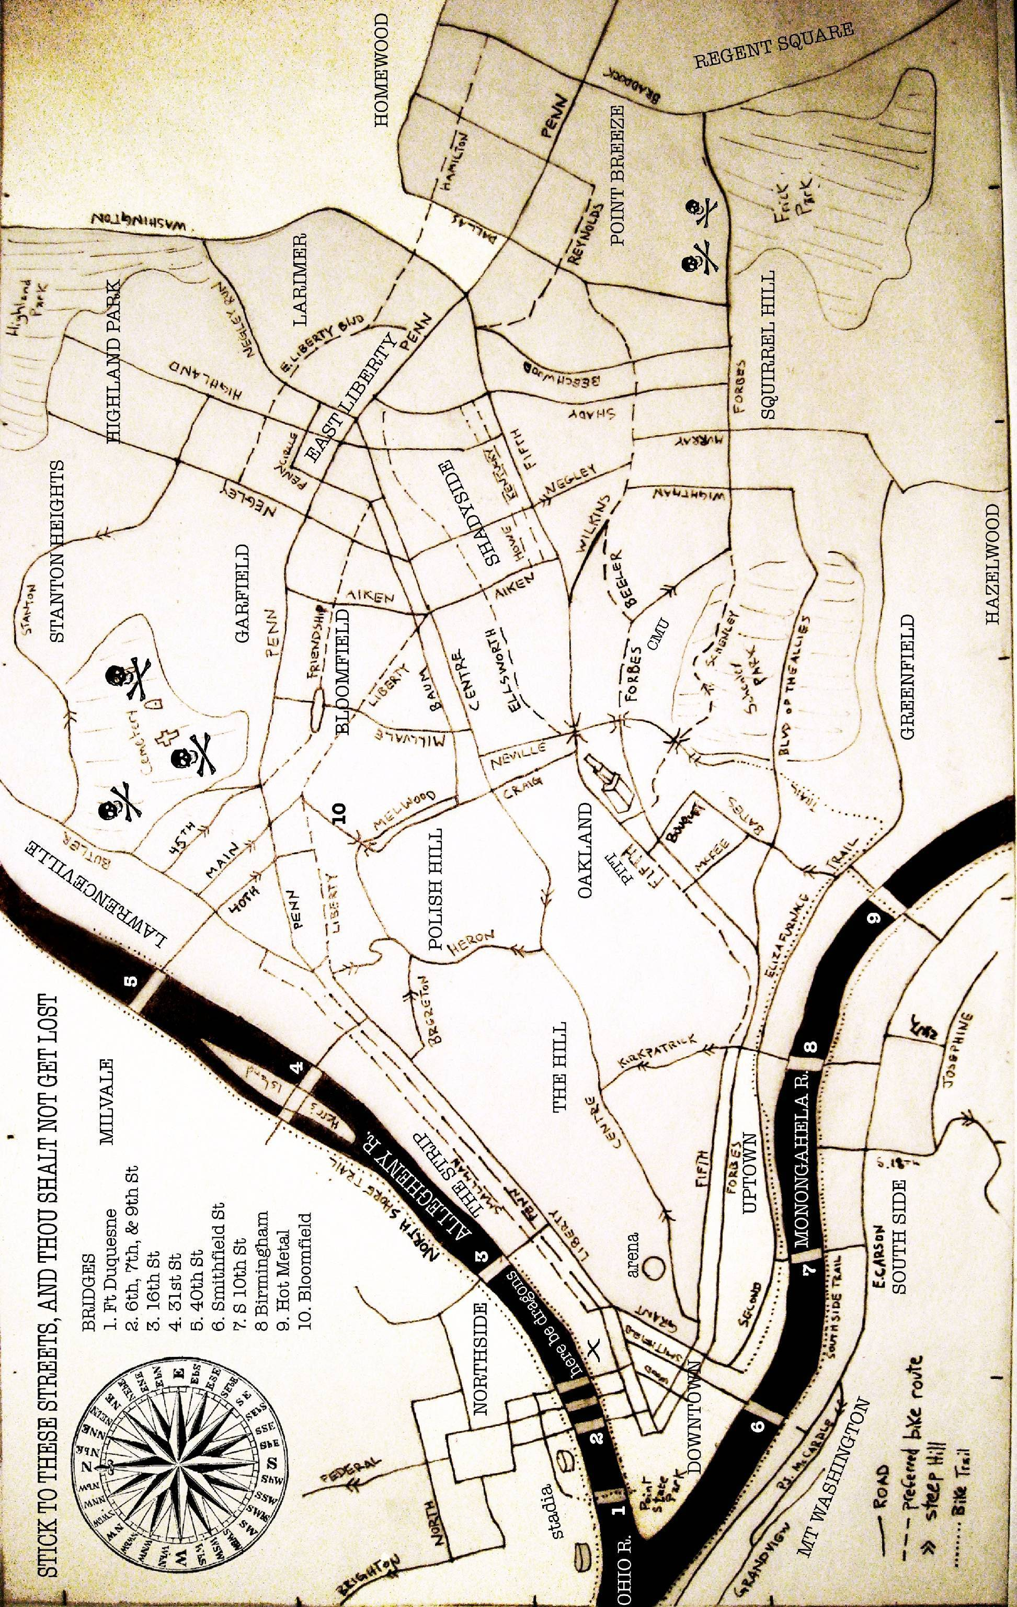

Maps of Downtown Pittsburgh

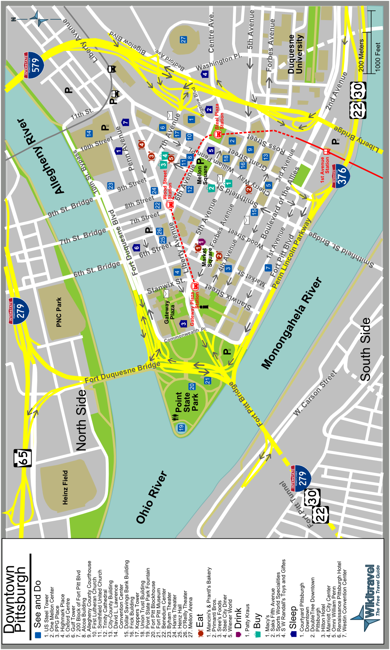

From: http://wikitravel.org/upload/shared/7/72/Pittsburgh_downtown_map.PNG
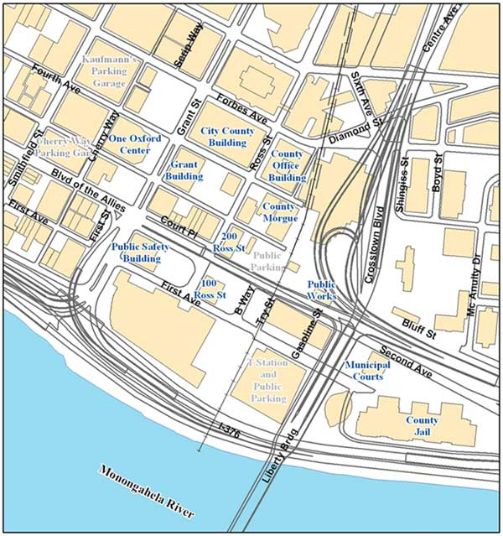

MEDICAL INFORMATION

Local Hospitals
Downtown:
UPMC Mercy Hospital
1400 Locust Street
Pittsburgh, PA 15219
412-232-8111

Northside:
Allegheny General Hospital
320 East North Avenue
Pittsburgh, PA 15212
412-734-6000

Southside:
UPMC Southside
2000 Mary St.
Pittsburgh, PA 15203
412-488-5550
Buses: 51B, 51G

Oakland:
UPMC Presbyterian
200 Lothrop St.
Pittsburgh, PA 15213
412-647-2345
Buses: 61 buses from town

MedExpress Urgent Care Centers (cheaper than emergency rooms)
Open 9 am to 9 pm, 7 days a week.
Illness: Rashes, allergic reactions, dehydration, and more.
Injury: Strains, sprains, fractures, dislocations, scrapes, cuts, minor surgery, and more.
3433 William Penn Hwy.
Pittsburgh, PA 15235
412-825-3627
East of Pittsburgh, 10 miles from downtown

50 Freeport Road, Suite 500
Pittsburgh, PA 15215
412-782-3278
North of Pittsburgh, 7 miles from downtown

7219 McKnight Road, Suite F
Pittsburgh, PA 15237
412-367-3278
North of Pittsburgh, 7 miles from downtown
Free/Sliding Scale Clinics
Hill District, near Downtown:
Hill House Health Center
Monday 10:30 am-7:00 pm, closed for lunch 2-3 pm
Tuesday-Friday 9:00 am-5:30 pm, closed for lunch 1-2 pm
1835 Centre Ave.
Pittsburgh, PA 15219
412-261-0937
Buses: 81B

Southside:
Birmingham Clinic (free)
Monday 6:00 pm-9:00 pm
Wednesday 1:00 pm-4:00 pm
Saturday 10:00 am-12:00 pm
Salvation Army Complex
44 South 9th Street
Pittsburgh, PA 15203
412-692-4706
Buses: 51A, 51C, 51G

Oakland:
Community Human Services Health Station
374 Lawn St.
Pittsburgh, PA 15213
412-621-4708
http://chscorp.org/Health.htm
Buses: any 61 goes here from downtown
Pittsburgh G20 Medics

There will be medics present at G20 events. This info to follow and more info at
http://resistg20.org/medics
“If you or someone around you is in need of medical attention, look around. Marked street medics commonly wear patches or red crosses on their clothes and equipment, but not all medics follow this convention. If you are unable to locate anyone nearby who is clearly an aid provider, simply yell "Medic!" Others may relay this message and if medics are in the area they will come to your location as quickly as possible. Be mindful of where you are located in relation to the police. If there is an ongoing confrontation or violence, try to move a short distance away if at all possible while calling for assistance. If you are unable to move yourself or the injured person away, make sure those around you know that aid is needed as soon as possible.
If you are a trained street medic, or are interested in being trained and are looking to plug in with the medical infrastructure, contact medics@resistg20.org. Also, if you need to request medical coverage at an event in advance, please notify us as early as possible. Advance notice is always appreciated, as we would like to provide a trained medical presence to as many people as we can. We will do our best to cover as many locations as possible, but may not be able to be everywhere at once.
There are activist medics coming from all over the country to help contribute to our medical response during the Coal Conference and G-20. We are excited to have this opportunity to help keep people as safe as possible, while providing aid to both fellow activists and the Pittsburgh community at large.”

Stay Healthy So You Can Stay in the Streets
Some suggestions from the Street Medics on what you can do before, during, and after a demonstration to stay well and keep fighting!
Before you leave home:
- Check the weather and prepare for it. See below for ideas of what to wear and what to bring.
- Make sure you have solid housing plans. Housing is almost always tight at these events, and the police may harass folks on the street. Large demos often list housing options on the web.
- Set up an emotional support system now. If you can, have a few days free when you get back. You may need time to process your experiences, catch up on sleep, and generally relax.
- Set up legal support at home now. Even if there is a legal support system at the demo, it can’t provide the same individual advocacy as the folks who know you. If you can, have a legal plan which includes someone who will not get arrested who is holding on to important information including your plan if arrested (give your name or not); who should be contacted if you are arrested; any medications, food or other needs you may have in jail; any responsibilities that need to be taken care of if you don’t get home as planned (work, animals, etc); if you are likely to be targeted by police for anything (including gender identification and trans issues, race, previous arrest, immigrant status) and whatever else seems relevant. For more information on legal issues see http://www.nlg.org.
- Consider talking with someone about your hopes, fears and expectations. By talking through what could happen and how you might respond you can prepare yourself for any difficult situations that might come up. See healingtrauma.pscap.org/peer.html for more info.
- Find out as much as you can about the plans for the demo (via demonstration websites, IndyMedia: http://www.indymedia.org/en/index.shtml, etc), but don’t count on this information too much, since it may change or it may be based on rumors or misinformation rather than actual plans.
- Get training in skills and information useful for demos: know your rights, health and safety for demonstrations, nonviolence, direct action tactics, etc.
Don't forget the basics:
- Do your best to get enough sleep.
- Eat healthy foods, and be sure that you eat enough. Avoid fatty or fried foods since they stress your liver (see chem weapons below.).
- Drink enough water – 3 liters (12 cups) a day, if you can. Start drinking extra water several days before the event to build up the fluid in your body. People can get dehydrated in cold and hot weather, so drink water whatever the weather.
- Minimize caffeine, cigarettes, alcohol, and other drugs. They stress your system and may decrease your reaction time, making you more vulnerable.
- Relax, focus, center. If you have something you use to relax yourself (music, meditation, whatever) consider doing this on the days leading up to and the days of the protests.
What to Wear:
- Wear clothing that protects your skin from sun, chemical weapons and injury. Consider long sleeves, pants, and a water-repellent outer layer. You can cinch clothing at wrists and ankles to keep chemicals out. Beware of overheating and getting dehydrated in all these clothes
- If it will be cold, bring extra clothes since you may be standing around for a while. Try not to have fleece as your outer layer, since it soaks up chemical weapons.
- Some people believe that detergents trap chemicals in clothes, so consider washing your skin and clothes in castile soap before the demonstration.
- Don’t wear contact lenses since they can trap chemicals (tear spray, pepper gas) against your eyes, and can cause permanent damage.
- Wear sturdy, well broken-in, closed-toe shoes that you can run in. An additional pair of socks will help prevent blisters. Bring extra pairs of socks in case your feet get wet or dirty.
- If there is a chance of chemical weapons exposure (there almost always is), protect your nose, mouth and lungs. Gas masks work best. They are also heavy, conspicuous, and very hot. You can also use organic particle respirators available at hardware stores. Or try a bandana soaked with apple cider vinegar. A paper mask underneath will decrease skin irritation. Other vinegars, lemon juice, and water don't work as well, but are better than nothing.
- To protect your eyes use shatter-proof goggles, ski goggles or something else that forms a tight plastic seal (but not with foam against your skin, as this traps chemicals).
- Wear sunscreen if there’s any chance you’ll get burned.
- Any product containing oil (sunscreen, make up, moisturizer, etc) may trap chemicals on your skin, so consider going with just water-based products.
What to bring:
- Water. Bring lots of water – at least 3 liters (12 cups) a day – since people can dehydrate quickly in the heat. Even better than plain water, make your own rehydration fluid by mixing 1 teaspoon of salt and four teaspoons of sugar in 1 liter (1 quart) of water.
- Food, especially high energy snacks like nuts, fruit, energy bars.
- Any medications you take on a regular basis, in the original container along with a note from a doctor saying you must take this medication. If you can, have two bottles and two notes and leave one with someone else.
- Any assistance devices you use (cane, etc) especially if you would need them if arrested.
- A map.
- Money, if you are concerned about getting arrested and might want to bail yourself out.
- A camera, if you might want to document police actions or the demonstrations. Be aware that many protestors do not want their photos taken.
- Extra clothes or sunscreen, depending on the weather.
- A buddy! If you can, run with another person so you can protect and help each other. Talk with your buddy about how you are feeling, what is likely cause you stress, what you do to calm yourself down, and how your buddy can help you stay calm. Plan what you want to do if things get messy. Even better, work within an affinity group. For more information on affinity groups see the “direct action handbook” section of www.nornc.org/ and members.tripod.com/SOAWatchLocal/LocalPages/handbook.html
What to know:
- Police use fear as a weapon. The more you are prepared, the less they can intimidate and control you.
- The layout of the area. Think ahead about where you will go if there's trouble. Make a plan with your buddy/group for where you will meet if separated.
- The plan for the demonstration and your group, as much as possible
- The attitude of the cops, and how they might respond to protestors. Pay attention to what they are doing, where they are moving and what equipment they are carrying.
- How to contact legal help if you are arrested or otherwise detained. Write the legal contact number in indelible ink on your skin, in a place where you could see it when handcuffed.
- Where the medic treatment space is (see below), and where medics are on the street.
During the Demonstration:
- Drink lots of water. Really. Dehydration is dangerous. Prevent it.
- If you can, take breaks to eat, drink, pee and relax.
- Stay calm. If you start to get stressed, try to take a minute to relax.
- Do your best not to get separated from your buddy and your group.
- As you move keep an exit plan in mind at all times If you are exposed to chemical weapons (tear gas, pepper spray)
- If you have asthma or other breathing problems chemical weapons may cause a severe attack. Carry your inhaler, or avoid gas altogether.
- Don't panic. Calmly walk to fresh air - up on a hill, away from the crowds, etc.
- Even if you don't immediately feel affected by the chemicals get away from them, because they are still doing damage.
- The horrible burning feeling is usually temporary. It lasts 20 - 30 minutes if the chemicals are not washed off.
- Call for a medic, or someone who can do an eye flush. You can learn how to do an eye flush yourself at workshops given by medics.
- As soon as possible get out of your contaminated clothes. Put your clothes in a sealed bag and either throw them away or wash them later, several times, in harsh detergent. Shower in the coldest water you can tolerate, using lots of soap. Keep doing this for a few days, since warm water can re-activate any chemicals on your skin. If you can, find out if the medics have a decontamination center set up.
- After the immediate effects have passed, take it easy. You have just been exposed to toxic chemicals, and your body needs time to recover. Drink lots of water. Your liver filters the
toxins out of your body, so try to avoid putting more stress on it with alcohol and drugs.
- Long term effects of chemical weapons exposure include damage to the immune system and liver, menstrual disruption, possible miscarriage of a pregnancy and respiratory problems.
If it looks like you are going to get arrested:
- Your bag will probably be taken from you, so be sure that ID, meds and money are on your person (if you plan to give the police your name) You will probably get your stuff back, but
there are no guarantees. If you can, consider giving your bag, keys and other important stuff to someone who is less likely to get arrested.
- Make sure you have the legal #, if there is one, written in indelible ink on your skin, where you can see it if you are handcuffed.
- You may not be searched for a while so consider having the following on your person (not in a bag): cell phone (beware of any sensitive #s in memory), food, extra clothes, pen, paper. Also consider eating any food you have, if it is going to get taken away.
- If you want to get anything past a search, hide it now. Pens, phones, meds can fit nicely in the front of your underwear or bra but you also may get in trouble if they are found.
If you are put in plastic handcuffs
- Plastic cuffs have caused long-term nerve damage to people’s wrists. If you have pain, numbness or tingling in your hands at any time, immediately request that looser cuffs be put on. If one officer refuses, ask another, and don't stop asking until they change the cuffs.
- Try not to move around too much, as this can tighten the cuffs. Consider requesting that your hands be cuffed in front. Ask if anyone in your group can demonstrate how to contort
yourself so that you can get the cuffs in front.
- If you experience pain, numbness or other unpleasant feelings after the cuffs are removed, get this documented ASAP by a medical professional, get in touch with local street medics, and see action-medical.net/library/aftercare/handcuffs.htm
If you have a medical problem before or during detention:
- If you have a medical condition that could cause problems while you are being held, consider telling the police ahead of time. This may encourage them to respond more quickly if you need help. If you or anyone in your group starts having a medical problem tell the police ASAP (if you have the person's consent), and request immediate professional medical attention. Do this early, as it may take a long, long, long time for the police to do anything. If you don't get a response initially keep asking until help arrives. Consider using chanting or other group tactics to get the police to respond.
- While you are detained stay as calm as you can. The police may try to unnerve, dehumanize and generally stress you out. Try yoga, singing, meditation, sharing stories, telling jokes, etc.
- Police lie and manipulate. They will tell you things that aren't true (that your friends have blamed you, that you'll get out in an hour, etc.).
- Think about what good can come of your arrest. Can you do a skill-share with you cell mates? Learn new songs? Talk about favorite movies?
- Try to be supportive of your fellow arrestees. Everyone is probably stressed out – fighting or other nastiness just makes it worse.
- If police are abusive in any way (emotional, physical, violating your rights, etc.) note the officer's name and badge number. Try to remember as many specific details of the event as you can. If you have a pen, write it all down!
If you get hurt or sick:
- The street medics are here to help. We are a volunteer group of activists with training in first aid, chemical weapons decontamination, and basic protestor health. Look for folks with red crosses on their clothes, or call out "medic!” We'll do all we can to help.
- At some events there is a “medic treatment space” or “wellness center” where we can treat more serious injuries; provide massage, herbal medicine and other therapies; and provide care in a calmer environment. If there’s a convergence center, ask there for the location of the medic treatment space, or flag down some medics and ask them.
- If you can't find a medic, get away from the action. If the problem is serious, consider getting other help (such as calling 911 or going to a local hospital or clinic). - See list below
After the demonstration:
- For many people demonstrations are exciting and exhilarating. But even the most prepared and experienced protester can get traumatized. Even if you don't feel stressed, try to take it easy for a few days. Your body and ind have been through an intense experience and may need time to recover. See healingtrauma.pscap.org/peer.html for more info.
- If you have witnessed violence or been subjected to it yourself, you may have strong emotional reactions. This experience may trigger memories of previous traumatic events. If
you can, talk over your experiences with people you trust as soon as possible. Talking about the specifics of what happened might cause more emotional trauma, so consider focusing more on how you feel. Try to do this before sleeping.
- Eat nourishing food, get some sleep (after talking), relax.
- Try to avoid alcohol, cigarettes and other drugs – they can increase your emotional responses to trauma.
- Even if you don't feel terribly stressed you may have nightmares, a short temper or other reactions. This is very common, and may also be a sign that you might benefit from talking about the emotions brought up by your experience.
For more information:
www.action-medical.net (general street medic site)
www.bostoncoop.net/balm (Boston, Massachusetts street medics)
www.blackcrosscollective.org (street medics based in Portland, Oregon)
www.takethestreets.org (New York City medic collective)
Medical information produced by medics from the BALM Squad (Boston Area Liberation Medic Squad). Email bostonmedics@riseup.net with comments/questions. Anti-copyright, please copy and distribute.

